Project Design Phase-II
Technology Stack (Architecture & Stack)

Date | 31 January 2026
Team ID | LTVIP2026TMIDS52445
Project Name | Prevent User Deletion If Assigned to an Incident in ServiceNow
Maximum Marks | 4 Marks

Technical Architecture:
The system follows a 3-layer ServiceNow architecture:
- User Layer (Admin UI)
Admin initiates user deletion from the ServiceNow interface.
- Application Layer (Business Rule Logic)
A Before Delete Business Rule executes server-side logic.
It queries the Incident table using GlideRecord to check user assignment.
- Data Layer (ServiceNow Tables)
  - sys_user table (user records)
  - incident table (assignment validation)
If an assigned incident is found → deletion is aborted → error message shown.
If not found → user is deleted.
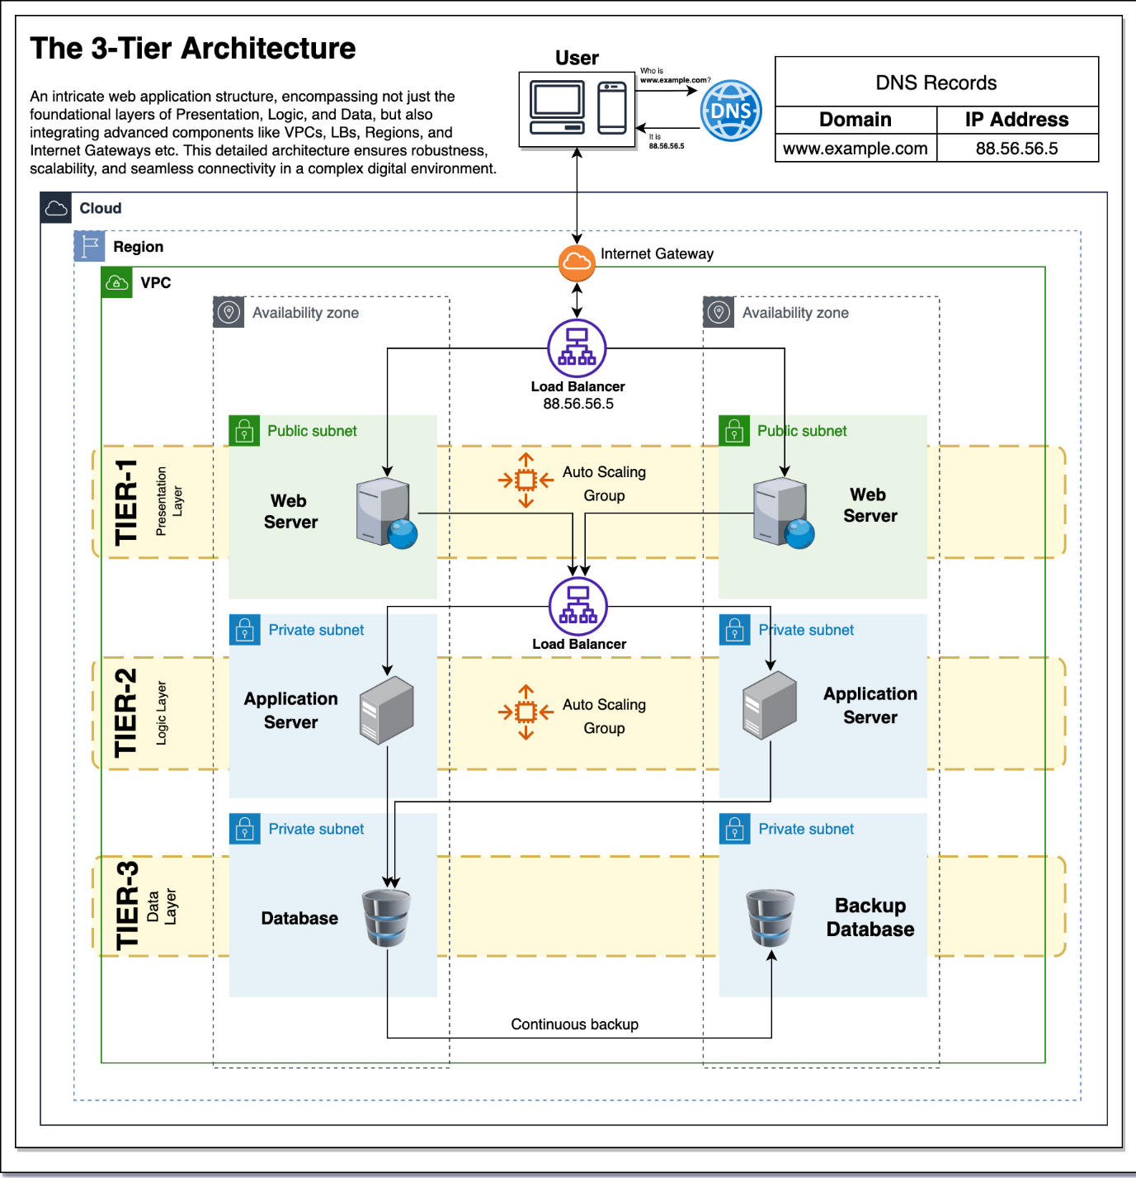

Table-1 : Components & Technologies:
S.No | Component | Description | Technology
1 | User Interface | Admin interacts through ServiceNow form to delete user | ServiceNow UI
2 | Application Logic-1 | Business Rule for deletion validation | JavaScript (Server-side)
3 | Application Logic-2 | Query incident records for assignment check | GlideRecord API
4 | Application Logic-3 | Display error message and abort deletion | gs.addErrorMessage(), setAbortAction()
5 | Database | Stores user and incident records | ServiceNow Tables (sys_user, incident)
6 | Cloud Database | Managed database on ServiceNow cloud | ServiceNow Cloud Data Store
7 | File Storage | Not required for this solution | N/A
8 | External API-1 | Not required | N/A
9 | External API-2 | Not required | N/A
10 | Machine Learning Model | Not applicable | N/A
11 | Infrastructure (Server / Cloud) | Hosted on ServiceNow cloud platform | ServiceNow SaaS (Cloud)

Table-2: Application Characteristics:
S.No | Characteristics | Description | Technology
1 | Open-Source Frameworks | Uses built-in ServiceNow scripting engine | JavaScript (ECMAScript in ServiceNow)
2 | Security Implementations | Server-side validation prevents client bypass; role-based access for deletion | ACL, Role-based access control
3 | Scalable Architecture | Business Rule can be extended to multiple tables (Problem, Change, Task) | ServiceNow server-side scripting
4 | Availability | Runs on ServiceNow cloud with high uptime | ServiceNow SaaS platform
5 | Performance | Optimized query using GlideRecord with setLimit(1) | GlideRecord API

